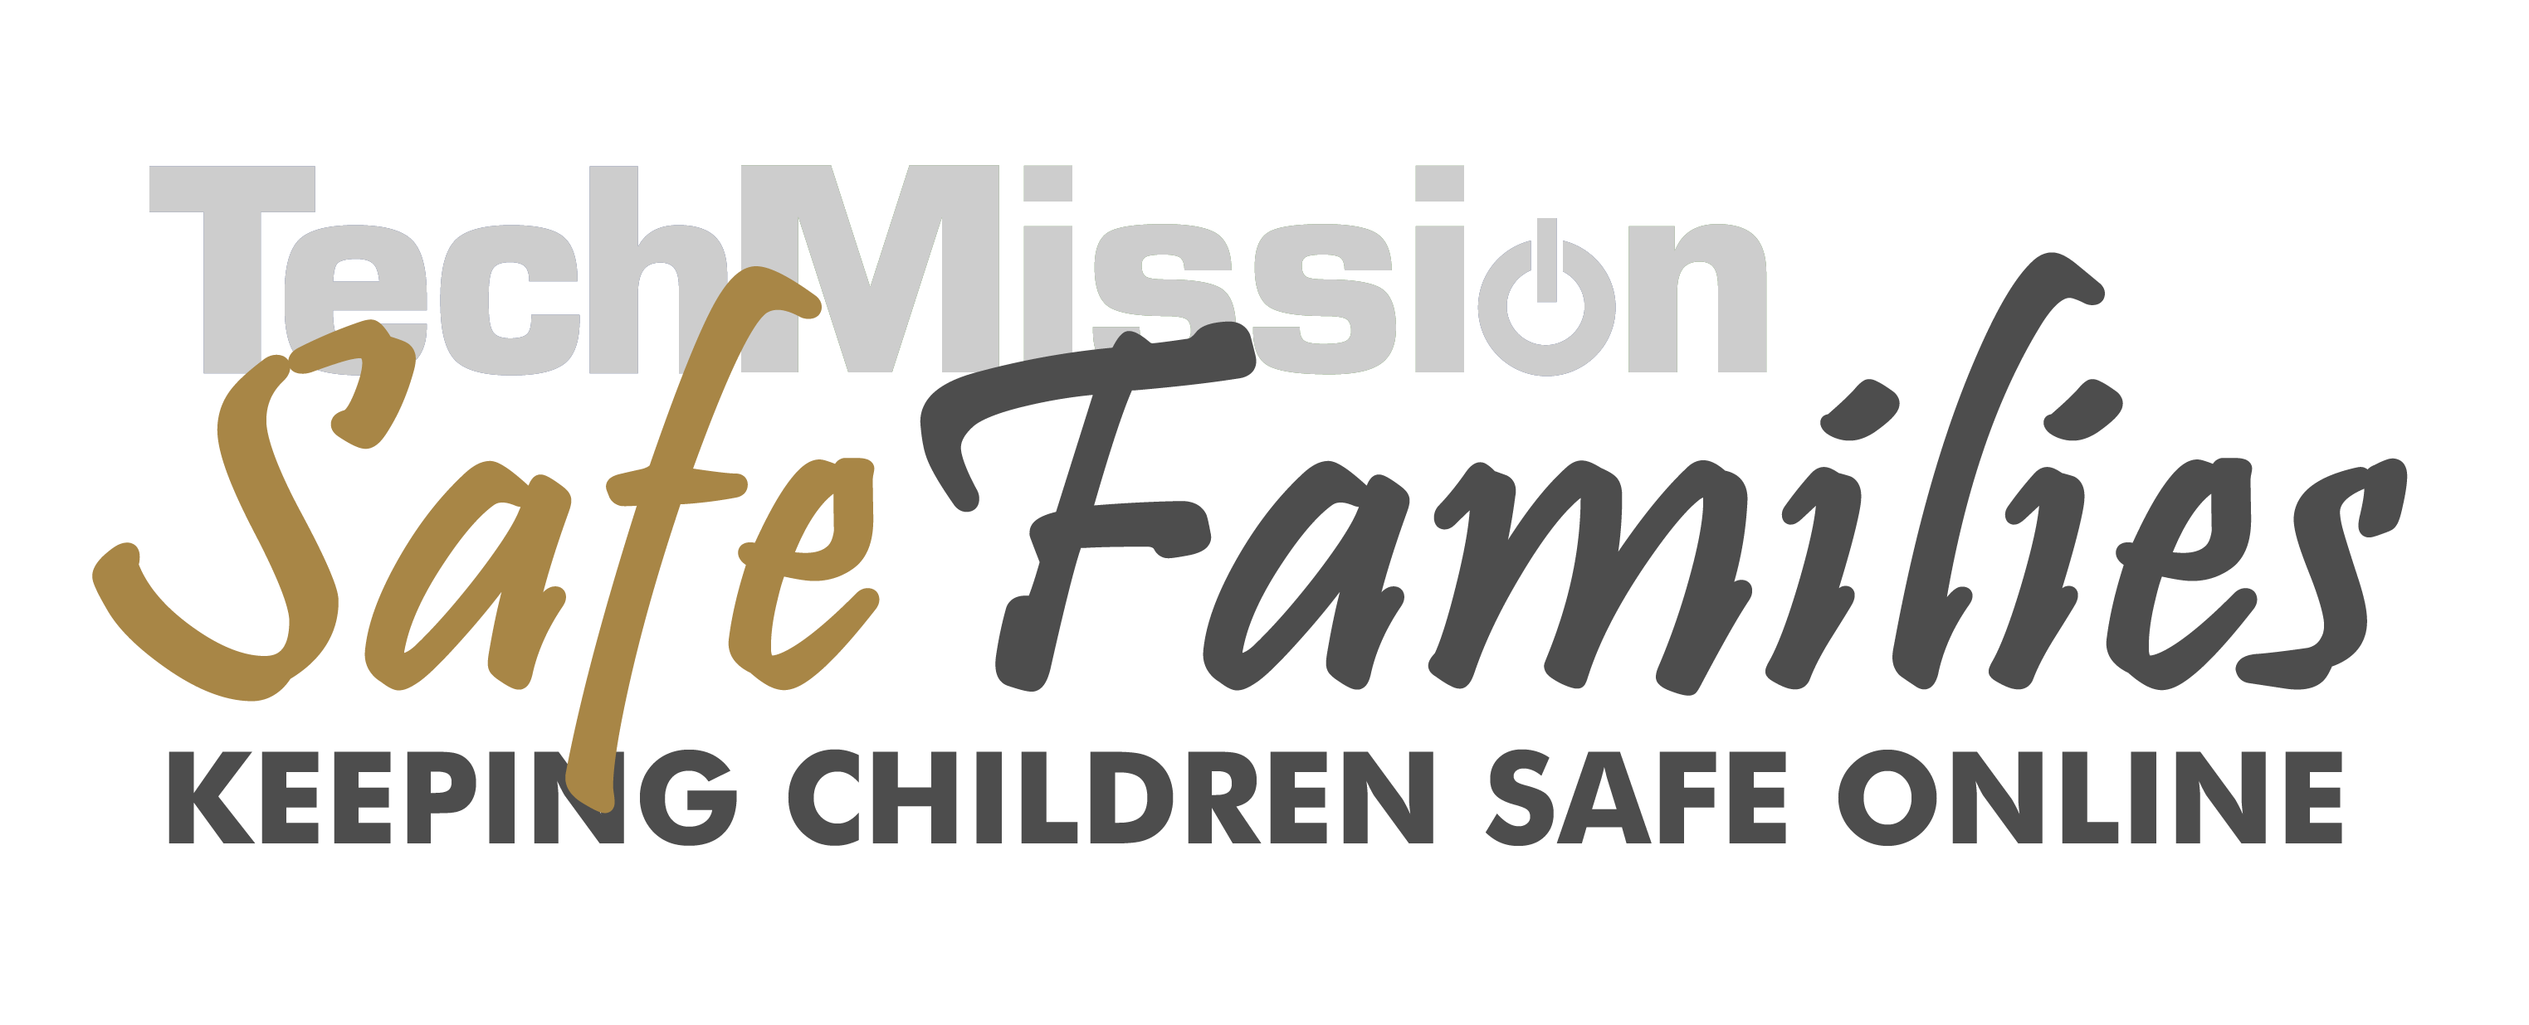
SAMPLE ACCEPTABLE USE POLICY

- All users must sign in before sitting down to work. No food or drink at or near the computers!
- If the application you are using has sound, please turn it off or use headphones.
- Users of the center are asked to remain in the labs, the hall ways connecting the labs and the restrooms to avoid disturbing other classes.
- No Rollerblades (or other skates) in the labs.
- The computer labs are only open for public access during posted hours. If you arrive before public access hours begin, please wait in the front hall. When asked to finish up because it's closing time, please be considerate and do so. The Center staff and volunteers reserve the right to ask anyone to leave the Center at any time for any reason.
- Be polite. Do not get abusive or threatening in your messages to or about others.
- Use appropriate language in conversation and online. Do not swear or use vulgar words.
- Chat rooms like BlackPlanet and file sharing services like Kazaa are not allowed.
- Obscene or sexually explicit material cannot be used in the Center.
- No illegal activity online or on the Center’s premises.
- Copyrighted material may not be used without owner’s permission. This includes piracy of computer software.
- Only Center staff members are permitted to load software on computers.
- Attempting to harm others’ data, computer equipment, or network performance is prohibited. This includes computer viruses.

I understand and will abide by this Acceptable Use Policy. I further understand that any violation of the regulations above may cause my access privileges to be revoked and may result in appropriate legal action against me.
User's Full Name: __________________________________
User Signature: ___________________________________Date: _______________

