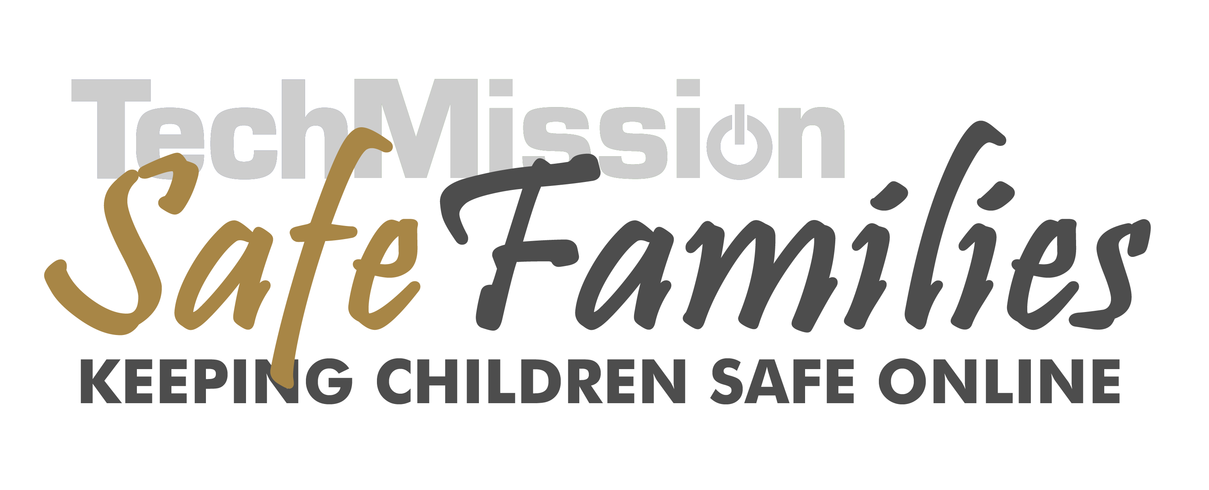

Checklist for Implementing an Online Safety Program in Your Computer Center

- Install Internet Filtering Software on all lab computers or install a server/router to filter all computers.
- Determine types of activities that will not be allowed due to content or function.
    - For content, banned sites should include all pornography and sexually explicit material; it could also include sites that are violent, gory, or that promote illegal drug use or hate.
    - Regarding function, we recommend that chat rooms, instant messaging, and file sharing not be permitted. You should consider this for so-called “online communities” such as BlackPlanet or MySpace, as well. We’d suggest that popular web sites of these activities be posted conspicuously on a “banned site list”.
- Develop and Post Acceptable Use Policy for Computer Center.
- Develop online safety orientation with presentations and activities for each age group. Present it to all regular lab users.
- After training, all participants should sign a copy of the Acceptable Use Policy; keep their signed copy on file.
- Always have a lab monitor in the room with participants, trained in enforcing the rules.
- Keep computers in a public area with screen easily visible to staff.
- For computers or user names mainly used by children, set the homepage to be a kid-friendly search engine.
- Outline rules for staff and volunteers as well.
(Organizations are vulnerable to sexual harassment or hostile workplace lawsuits for allowing employees to view and download pornography and can be liable to copyright owners if employees download files without owners’ permission.)

