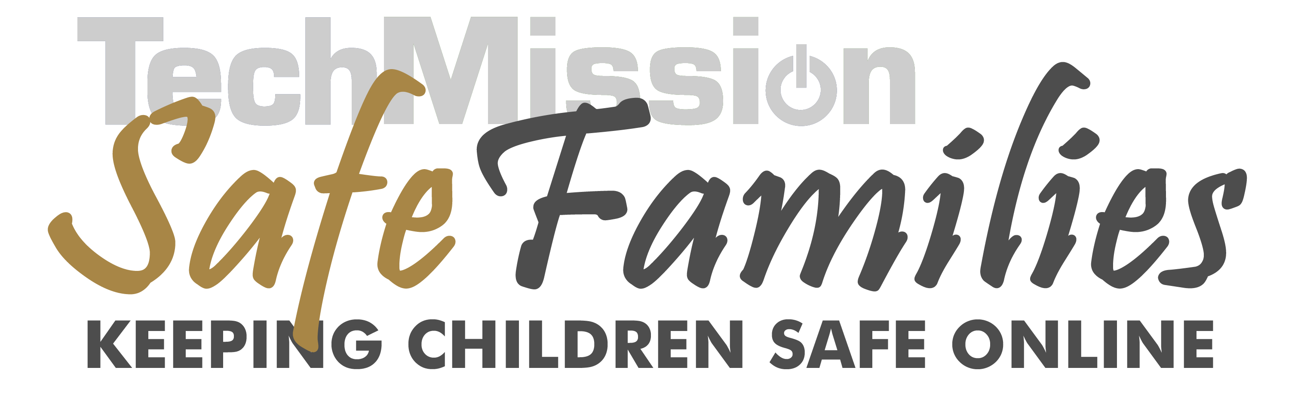

FAMILY INTERNET SAFETY PLEDGE
- I will not look at, download, or copy inappropriate or questionable material; if I’m not sure that something is OK, I’ll ask first. If I see something inappropriate or if I experience anything online that upsets me, I will tell my parents. I will not keep online secrets from my parents.
- I will not give any personal information (like my real name, address, age, phone number, school, passwords, or appearance) to anyone online or fill in online forms about myself without my parents’ or guardians’ permission. I will never send pictures without specific permission.
- I will not arrange to meet anyone in person that I find out about online without getting my parents’ permission and bringing an adult with me to a public place. I will not arrange to have a phone conversation with someone I meet online without my parents’ permission. I understand that people may not be who they say they are online.
- I will always be courteous in how I communicate to others; I will not use bad language, insult people, or be rude. I will respect the privacy of my friends and family.
- I will not purchase products or services online without my parents’ approval and help.
- I will not respond to email or an instant message from someone I do not know.
- I will follow my parents’ or guardians’ guidelines for when I can use the computer, for how long and what programs and games I may or may not use.
- If I am under the age of 16, I will not use chat rooms and I will only use instant messengers programs to communicate with those my parents or guardians have approved of.
- I will not install software programs without getting permission. I understand that peer-to-peer file sharing programs like Kazaa, Limewire or BearShare are not allowed.
- I will not use the computer to do anything illegal including illegal downloading of software, music or movies.
- These rules apply wherever I am (at home, a friend’s house, school, or the library).
- I understand that violating this pledge may result in loss of computer access, and I will accept these consequences.
We agree to the above.
Children sign below Parent(s) sign below

__________________________ __________________________
__________________________ __________________________
__________________________
__________________________
__________________________

